

Filing Suspicious Transactions
and Activities
Standard Operating Procedure

Binance ADGM

Document Version Control
Version: | 1.0
Date of Issue: | 05 January 2026
Document Owner: | Wilson Cheung, MLRO/CO of ADGM (Nest Exchange Limited & Nest Clearing and Custody Limited)  David Harrington , MLRO/CO of ADGM (Nest Trading Limited)
Next Review Date: | 05 January 2027

Version History, Approval and Sign-Off
Version No | Change Description | Author | Approval Authority & Department | Review &  Approval Date
1.0 | Initial implementation | ADGM MLRO | ADGM Board of Directors | DD Month YYYY
1.0 | Initial implementation | ADGM MLRO | Wilson Cheung, MLRO/CO of ADGM | 05 January 2026
1.0 | Initial implementation | ADGM MLRO | David Harrington, MLRO/CO ADGM | 05 January 2026

Table of Contents
1. Introduction 4
2. Scope 4
3. Approval & Annual Review 5
4. Roles and Responsibilities 5
5. Procedures 6
5.1. Escalation types and origination 6
5.2. External report options 7
5.3. Identification of Suspicious Activity, Initial Review and Investigation 8
5.4. MLRO Review and adjudication 9
5.5. Quality Assurance & Calibration 10
6. What warrants a SAR Filing 11
8. Freezing of Assets 13
9. External Requests 13
10. Submitting the report via HaoDesk and XML auto reporting functionality 13
11. Manual reporting via goAML (FIU) 15
12. Uploading an XML report 15
13. Submitting a Web Report 17
14. Escalation 18
15. Record Keeping 18
Appendix 1 - GoAML high risk indicators 19
Appendix 2 - expedited review & reporting SLA 21

Introduction
Nest Services Limited, Binance (AD) Limited and BCI Limited (“Binance” or the “Firm”) are regulated by the Financial Services Regulated Authority (“FSRA”) in the Abu Dhabi Global Markets’ (“ADGM”). In line with its obligation, as documented in the AML Policy, Global Sanctions Policy, the Compliance Manual, and as per the UAE’s Executive Office for Control and Non-Proliferation (EOCN) and the Financial Intelligence Unit (FIU) reporting requirements, the Firm must report:
- Any suspicious activities or transactions to the UAE FIU when, in the course of carrying on business, it becomes aware of, suspects, or has reasonable grounds to believe that such activity has occurred.
This document sets out the procedures and responsibilities for external reporting to the FIU, including identifying, evaluating, escalating, and reporting Suspicious Activity or Transactions (SARs/STRs) in accordance with UAE Federal AML laws. It ensures the Company complies with:
- Federal Decree-Law No. (20) of 2018 on AML and CFT
- Cabinet Decision No. (10) of 2019
- ADGM AML/CTF and Sanctions Rulebook
- Guidance issued by the EOCN regarding reporting suspicious activity and Transactions relating to money laundering, terrorist financing and proliferation financing
- goAML Reporting Requirements issued by the UAE FIU
To this end, Binance has adopted this external FIU Reporting Standard Operating Procedure (“the Procedure”), which sets forth guiding principles that are applicable to the Firm. The procedure complies with regulations stipulated under the ADGM AML/CTF and Sanctions Rulebook.

Scope
The Procedure is primarily designed to assist central compliance operational teams and the Binance local compliance team in determining the appropriate actions to take when a customer's transaction or activity is flagged, and to apply the correct remedial measures.
The procedure will be applied to all Binance users and any prospective users onboarding or migrating to Binance.

Approval & Annual Review
This procedure must be reviewed and approved at least annually, or when triggered by events such as regulatory or audit findings, system enhancements, or other significant changes, by the ADGM Board of Directors. The Global Chief Compliance Officer (GCCO) is authorized to approve interim updates.

Roles and Responsibilities
No | Role | Responsibility
1 | Transaction Monitoring Team | Use automated systems and rule-based alerts to monitor transactions for unusual or potentially suspicious activity.  Perform the first-level review of generated alerts to determine whether further investigation is warranted and escalate to the relevant teams if necessary.
2 | Sanctions Team | Conduct real-time screening of customers and transactions against sanction lists and high risk countries, and escalate true/partial name match or High Risk country hits to the MLRO for reporting.
3 | Investigation Team | Conduct in-depth analysis of alerts escalated from the Transaction Monitoring or Sanctions Teams, reviewing transactional behavior, customer profiles, and relevant documentation.  Escalate cases to MLRO for final decision-making.
4 | ADGM SAR Analysts | The ADGM MLRO has a standing delegation to the ADGM SAR Analyst for the purpose of external SAR filling.  Ensures that all suspicious transactions and activities are filed externally to the UAE Financial Intelligence Unit (FIU).
5 | MLRO / Deputy MLRO and SAR Analysts as delegates of the MLRO | Review escalations and make the final determination on whether the case requires external reporting.  Prepare and submit the appropriate report (e.g. SAR, STR, CNMR, PNMR) to the appropriate regulatory or law enforcement body within the mandated timeframe when necessary.  Respond to any subsequent requests from UAE FIU.

Procedures

Escalation types and origination
- Referral of suspicious activities (L1) - All Binance Group employees are required to stay vigilant, to identify and escalate any unusual or potentially suspicious activity. As such, the MLRO may receive a direct escalation from any employee.
- SAR Investigation Team (L2) - once the team has conducted the investigation of the unusual transaction, activity or behaviour, they will make a recommendation of the next course of action and escalate to the MLRO (L3) if applicable.
- Sanctions Team (L2) - once the team has conducted their investigation in relation to Sanction or Combating the Terrorist Financing (CTF) matters, they will make a recommendation of the next course of action and escalate to the MLRO (L3) where applicable.
- Special Investigation Team (L2) - once the team has conducted their investigation in relation to law enforcement engagement, they will make a recommendation of the next course of action, and depending on the severity of the case, they may reach also out to the MLRO and relevant law enforcement agency to report suspicious activities of a Binance user under voluntary reporting to FIU.

External report options
The UAE’s Executive Office for Control and Non-Proliferation (EOCN) and the Financial Intelligence Unit (FIU) define the reporting requirements, along with the applicable report types available on goAML. The designated MLRO/Deputy MLRO of each reporting entity (Nest, Binance AD and BCI) is the registered user on the goAML portal and ultimately responsible for fulfilling the Firm’s reporting obligations, even in cases where they have delegated such duties to the SAR Specialist Analysts team.
Report types and reportable scenarios:
- Suspicious Transaction Report (STR) - to be used if during the establishment or course of the customer relationship, or when conducting transactions on behalf of a customer or a potential customer, the Firm suspect transactions related to money laundering, fraud or terrorist financing, then the MLRO or their delegates must submit an STR to the FIU promptly.
- Suspicious Activity Report (SAR) - to be used if during the establishment or course of the customer relationship, the Firm suspects any activity or an attempted transaction (i.e. a non-executed transaction) that can be related to money laundering, fraud or terrorist financing, then the MLRO or their delegates must submit a SAR to the FIU promptly.
- Additional Information File (AIF) - should the FIU require any further details while reviewing a STR/SAR, the Firm may be required to provide further information (i.e. an AIF request from the FIU received through the Message Board), the MLRO or their delegate must submit an AIF report with the requested information through the goAML portal.
- Partial Name Match Report (PNMR) - used to report any suspension measures taken upon identifying partial name matches to the Local Terrorist List or UN Consolidated List through the goAML platform within five (5) days from taking such measures.
- Confirmed Name Match Report (CNMR) - used to report any freezing measures taken upon identifying confirmed name matches to the Local Terrorist List or UN Consolidated List through the goAML platform within five (5) days from taking such measures.

Identification of Suspicious Activity, Initial Review and Investigation
Identification:
It is the responsibility for all employees to escalate to the central compliance team if they identify any suspicious activity during their ordinary course of employment.
In practice, Suspicious Activity can typically be identified via transaction monitoring alerts, sanction alerts, employee reports, or external requests.
The Firm’s central compliance team is responsible for escalating alerts generated by the Transaction Monitoring systems or sanctions screening tools.
The alerts are generated based on predefined rules in the On-Chain and Off-Chain Transaction Monitoring Procedures or due to matches to the sanction lists maintained by the global sanctions team.
Initial Review:
Once an alert is generated, the Transaction Monitoring or Sanctions Team will review the alert for false positives.
Valid alerts will be escalated to the Investigations Team for further review.
In the event of activity, which requires Immediate Attention or Complex Investigation, the alert will be subject to expedited review and escalation:
Activity requiring immediate attention include reportable violations that are ongoing, e.g.:
- Linked to an ongoing money laundering scheme as indicated by an appropriate LE authority), and
- Transactions that the LFI suspects are related to the financing of terrorism and illegal organisations.
Complex Investigations include:
- Employee-related investigations,
- Significant investigations involving multiple customers-, jurisdictions-, accounts-, transactions-, and/or subpoena requests;
- Legal referred investigations

Investigation:
The Investigations Team will conduct a detailed review of the user’s information and activity. The review will consider:
- Customer KYC information
- Transaction history
- Counterparties
- Law Enforcement Requests
- External open-source checks (where applicable)

Upon completion of the investigation, the internal investigation team shall prepare a report of their findings. The report shall include:
- Source or trigger for the internal investigation,
- The scope of the investigation,
- The outcomes and findings,
- The recommendation as to whether the user should be offboarded or retained and monitored.
The report is to be submitted to the FSRA’s approved MLRO or its delegate, and any other relevant MLROs of other Binance Group’s companies (if applicable) where all or part of the potential suspicious activity or transaction took place.
In the event of escalation for expedited review, the alert review-, investigation- and reporting of an initial STR or SAR to the FIU, must be completed within 15 business days of the alert generation.

MLRO Review and adjudication
The MLRO may delegate its review/adjudication authority to the Deputy MLRO(s) and ADGM compliance analysts “MLRO delegates". The MLRO delegates will review the escalation or case file submitted by the Sanctions or Investigation Teams, including any recommendations provided.
Based on the available information, the MLRO delegates may return the case to L2, request further information, and/or initiate further investigation into the suspicious activity or transaction.
If the activity is deemed suspicious, the MLRO’s delegates will decide whether to retain and monitor or offboard the user.
The MLRO delegates will assess whether the escalated activity warrants the filing of an external report to the local authorities, the UAE Financial Intelligence Unit (FIU).
Based on Binance’s business model and large volume of reportable items, all SARs/STRs will be filed under Binance AD / RCH (covering the activity under all 3 entities). This was aligned with Me.Saheen Shaju Marakkar and Mr. Ali Hassan Obaid Hassan Alshehhi of UAE FIU on 14 November 2025 by email. In short, Binance AD / RCH is delegated to file any SARs/STRs on behalf of any of the 3 ADGM entities to save for any duplicated SARs/STRs filing as all clients automatically become clients of all 3 ADGM entities at time of onboarding. Both MLROs will be subscribed to the goAML portal under Binance AD / RCH (with Nest and BCI as sub-accounts).
As required, the MLRO or their delegate, will be responsible for submitting the external reports to the UAE FIU.
SARs/STRs must be submitted “promptly” and “without a delay” from the point a suspicion is formed. A reasonable timeframe from the escalation to the MLRO is generally considered to be within the same business day or no later than 24-48 hours.
In the event of escalation for expedited review, the MLRO / MLRO delegates should:
- Review and determine if it is suspicious within 24 hours of the date of escalation, and
- File an STR or SAR to the FIU within 24 hours of the determination.
CNMR/PNMRs must be submitted within five (5) business days from the point of freezing / suspension measures.

Quality Assurance & Calibration
Quality Assurance:
The MLRO/Deputy MLRO will conduct periodic quality assurance reviews on a sample basis, in order to ensure the reports were filled in a timely manner and in compliance with the set regulatory reporting standards.
The QA review must be conducted with a reasonable sample size of the total reported case volumes.
Any findings related to training needs or necessary corrective action must be recorded on the QA Tracker and actioned in a timely manner.
Calibration:
The MLRO/Deputy MLRO will hold periodic calibration sessions in order to ensure that adjudication of suspicious activity escalations and subsequent reporting is consistently applied across the ADGM Compliance Analysts team.
In addition, the MLRO/ Deputy MLRO will hold periodic feedback sessions with the FCI team, in order to ensure alignment between the investigation of a transaction or activity, and the filing of the external report.

What warrants a SAR Filing
Activities, which may raise suspicion include, but are not limited to:
- Transactions which have no apparent purpose, which make no obvious economic sense, or which are designed or structured to avoid detection;
- Transactions requested by a Person without reasonable explanation, which are out of the ordinary range of services normally requested or are outside the experience of a Relevant Person in relation to a particular customer;
- Where the size or pattern of Transactions, without reasonable explanation, is out of line with any pattern that has previously emerged or may have been deliberately structured to avoid detection;
- A customer's refusal to provide the information requested without reasonable explanation; (e) where a customer who has just entered into a business relationship uses the relationship for a single Transaction or for only a very short period of time;
- Extensive use of offshore accounts, companies or structures in circumstances where the customer's economic needs do not support such requirements;
- Unnecessary routing of funds through third-party accounts;
- Unusual Transactions without an apparently profitable motive.

As per EOCN’s national guidance, typologies and red flags for ML, TF, and PF are listed below. Common indicators include:
- Frequent, unexplained fund movements
- Rapid conversion between fiat and crypto
- Structuring to avoid thresholds
- Use of third-party accounts
- Sanctions evasion via intermediaries
Always consider the context, what is unusual for one customer may be normal for another.
For those that are involved in any illicit activity, the users will be automatically offboarded. If a user conducts another activity that is against the platform’s terms of use, the user can be offboarded and an external SAR/STR will be submitted to the UAE FIU.
The Firm has zero risk appetite for direct sanctions exposure. Transactions over $0 that raise alerts due to direct exposure to sanctioned jurisdictions/entities will be offboarded without any warning and an external SAR will be filed.
- Suspension of products and services

Where the Sanctions team, in the course of routine sanctions screening, have identified a Partial Name Match on an existing customer, prospective customer or counterparty of an existing customer in a transaction, and taken measures to suspend any transaction, refrain from offering any funds, other assets or services, the MLRO or their delegate is required to submit a PNMR through goAML within five (5) business days from the suspension measures.

The MLRO must ensure that all necessary information and documents regarding the Partial Name Match are also included in the report.

Once further instructions are received from EOCN via goAML on whether to cancel the suspension (‘False Positive’) or implement freezing measures (‘Confirmed Name Match’), the MLRO must notify the Sanctions team for the execution of the necessary action.

Freezing of Assets
Where the Sanctions team, in the course of routine sanctions screening, have identified a Confirmed Name Match on an existing customer, a prospective customer or counterparty of an existing customer in a transaction, and taken measures to freeze and prohibit making funds or other assets or services available, the MLRO or their delegate is required to submit a CNMR through goAML within five (5) business days of implementing the freezing measures.

In addition, the FSRA and ADGM Courts have certain powers under the relevant laws to impose a requirement restricting Binance from disposing of or transferring property including, for example, assets or other funds suspected of relating to money laundering or terrorist financing. Upon receiving a request from FSRA/ADGM Courts on freezing of assets, Binance is required to comply with the instructions and take all required actions accordingly.

External Requests
The local Compliance Team may receive Law Enforcement (LE) requests from external authorities, such as the FIU or FSRA. These requests can range from general Requests for Information (RFIs) to specific instructions for the Firm to submit a SAR/STR related to certain users.
The MLRO must submit the external SAR/STRs as requested by the LE request in a timely manner.

Submitting the report via HaoDesk and XML auto reporting functionality
As per Chapter 14.3 of ADGM’s AML/CTF and Sanctions Rulebook, MLROs are responsible for reporting any suspicious activity or transaction to the UAE FIU.
When an activity or a transaction is deemed suspicious by the MRLO, the MLRO has the duty to submit a report of the activity to the Financial Intelligence Unit via their goAML website.
A new functionality has been built to facilitate automatic reporting via HaoDesk and an API link to the FIU’s reporting portal, GoAML.

An illustration of the auto-reporting process is provided below:

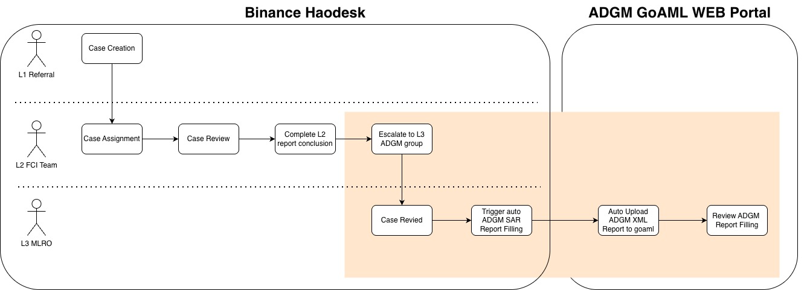

Process steps:
- L1 Referral create ICR case in HAODesk
- L2 FCI Team perform their investigation and compiles their full case narrative
- When required and according to the case decision matrix in the L2 SOP, L2 FCI Team escalate to L3 ADGM Specialist Analysts
- L3 ADGM Analysts / MLRO delegate performs their review to adjudicate the case
- Depending on the review outcome, L3 ADGM Analysts may trigger an external SAR or STR filing to ADGM GoAML portal
- ADGM Analysts / MLRO delegate is required to select one (1) or more of twelve (12) possible Risk Indicators under “Reasons to file” - see Appendix for more details
- ADGM Analysts / MLRO delegate is required to provide a rationale for filling / not filling a report and ensure all necessary reporting information is captured
- When ADGM Analysts / MLRO delegate selects “Yes’ to indicate that the case requires reporting to the FIU, a new Button “Report to FIU” will appear
- Upon selection of “Report to FIU”, the system will automatically upload XML report to the ADGM GoAML portal.
- In the cases where the ADGM Analysts / MLRO delegate confirms that a SAR must be filled, the Customer Risk Rating / CRR should be raised to High via BinanceAdmin, which will consequently trigger Enhanced Due Diligence / EDD and monitoring.

Manual reporting via goAML (FIU)
In the event of system unavailability and/or where the auto-filling functionality is not present in HaoDesk, the L3 ADGM Analysts is able to use the manual reporting functionality to fulfill the Firm’s reporting obligations.
The ADGM Analysts / MLRO delegate must log into Binance’s GoAML account to be able to file the SAR/STR report.
They can do so via the following link: https://services.uaefiu.gov.ae/goaml/Home.
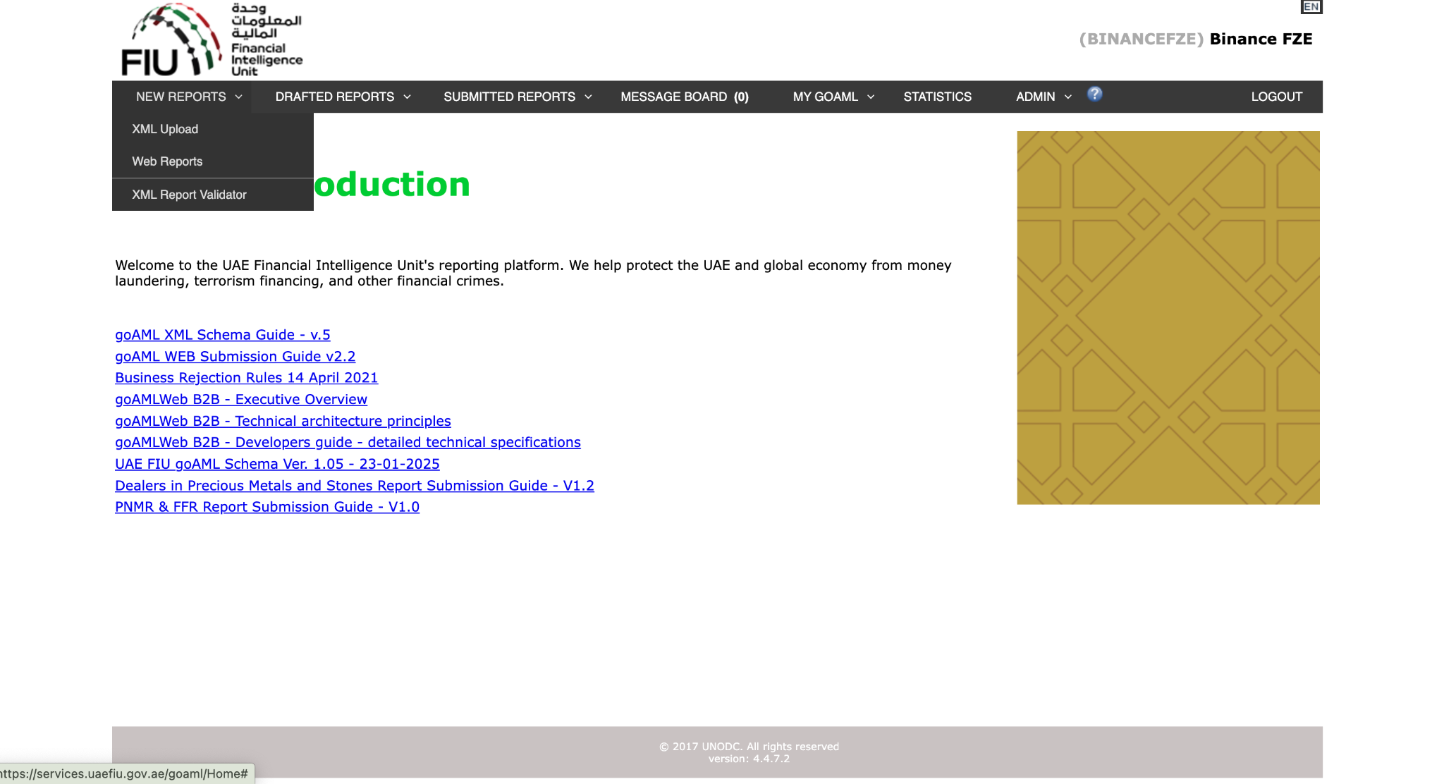
The ADGM Analysts / MLRO delegate can choose to upload an XML file or submit a Web Report (least preferred option).

Uploading an XML report
In the event of system unavailability and/or where the auto-filling functionality is not present in HaoDesk, the ADGM Analysts / MLRO delegate may upload individual XML report files, or multiple XML reports in a ZIP file, to the GoAML portal.
The link for uploading reports is accessible by hovering the mouse pointer on the menu bar:
New Reports > select XML Upload
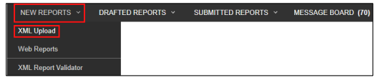
Click on Browse and select the XML file to be uploaded. The user can select either a
single XML file or a zipped file. In case of a zipped file, the user may enter multiple XML
files along with attachments granted that they are in the appropriate format as depicted
below:
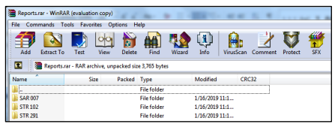
Click on Upload. The data is then uploaded to the goAML for acceptance or rejection.

Submitting a Web Report
The ADGM Analysts / MLRO delegate can choose to submit a Web Report, where all other reporting options are unavailable. They must choose either the option to submit a STR or SAR. The information that needs to be submitted will vary depending on the type report.

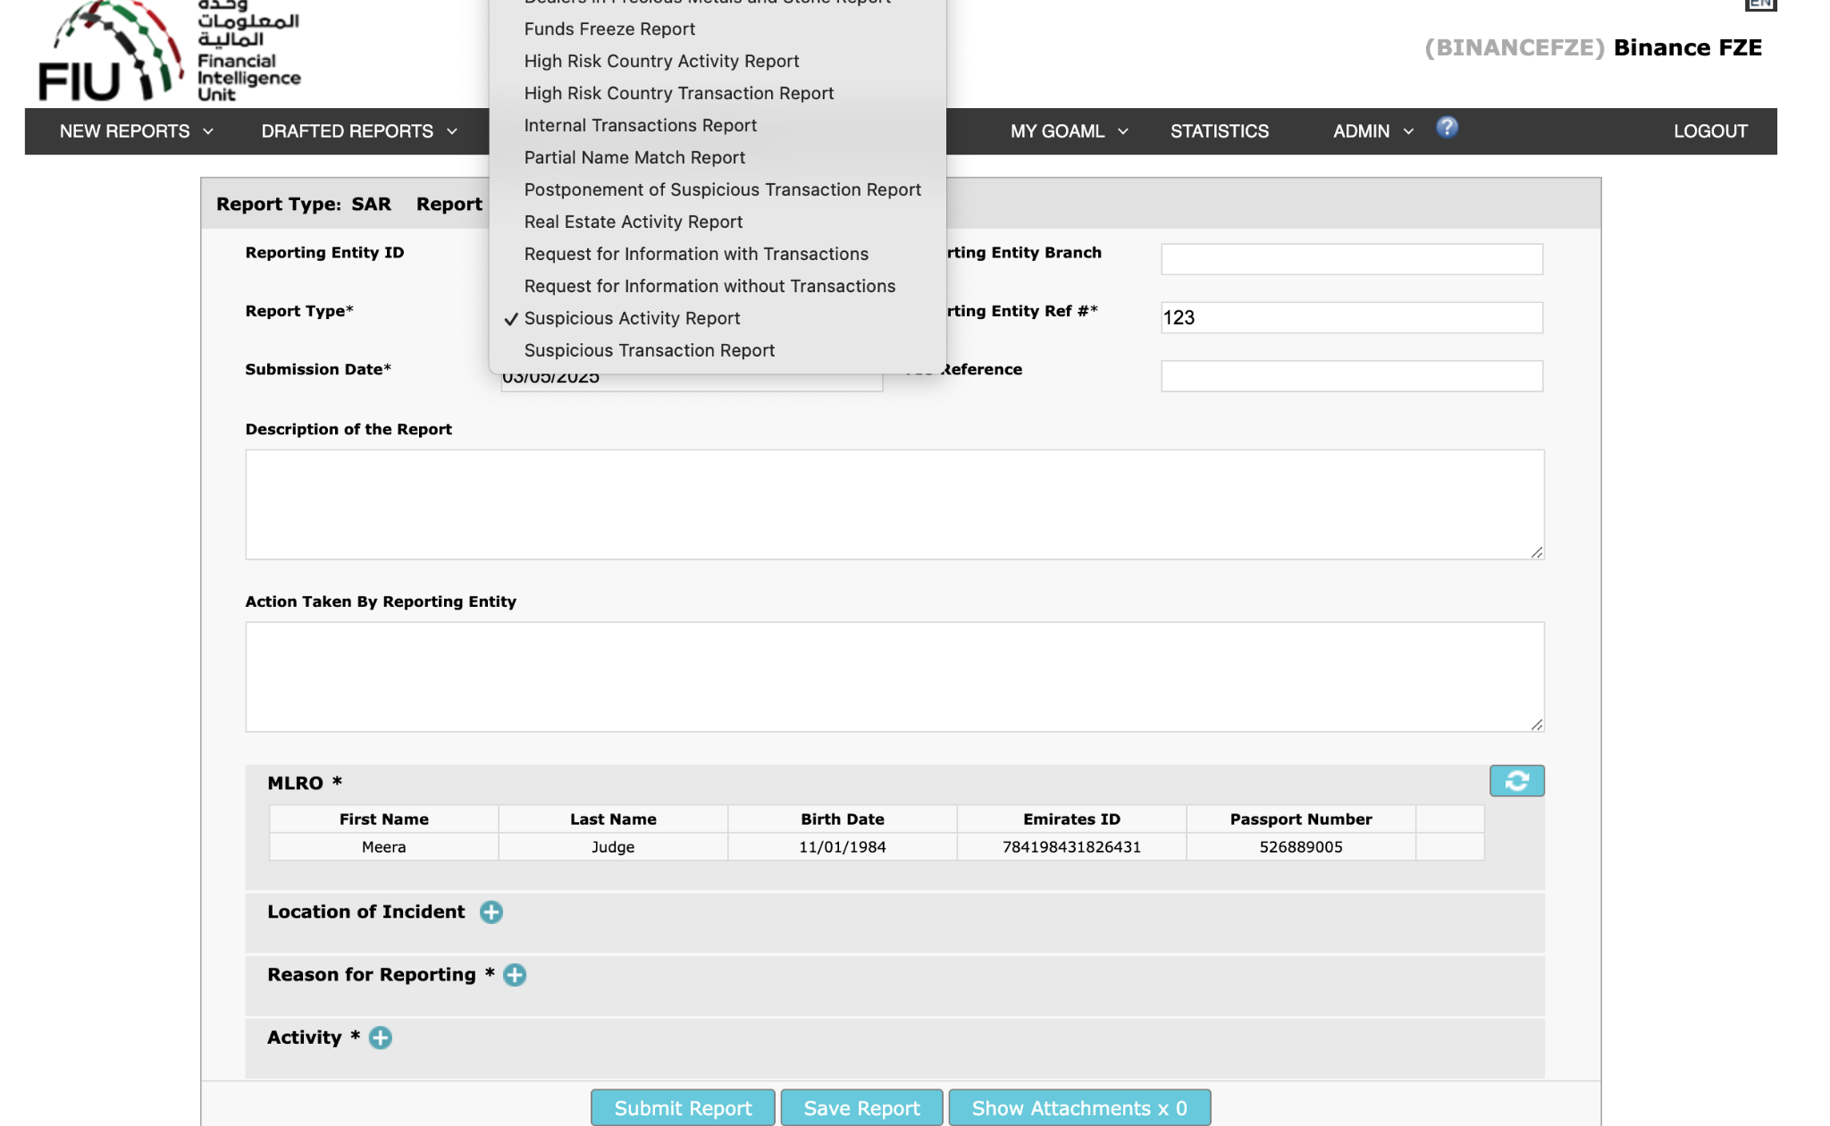

The MLRO must fill in the necessary information such as:
- Reporting Entity Ref# (user’s UID);
- Description of the Report;
- Action Taken by Reporting Entity;
- Location of Incident (the entity or individual’s address);
- Reason for Reporting; and
- Activity or transaction being reported
- When submitting an Activity, the parties involved in the activity must be recorded.
- Both the entity and the related parties must be recorded if the transaction/activity was conducted by a KYB user.

Escalation
Any delays or failure to meet set reporting timeframes, unusual cases, or legal concerns must be escalated to the MLRO immediately.

In the unlikely event of a disagreement between the MLRO and Deputy MLRO, the matter must be escalated to the Group Chief Compliance Officer and/or the Audit, Risk & Compliance Committee.

Record Keeping
All FIU reports filled via GoAML and related documentation, must be stored securely for at least six (6) years from the date the report was filed. This includes supporting information in relation to suspicious activities (e.g. wallet addresses, crypto transactions etc.), as well as documentation used to assess reported Confirmed or Partial Name Matches.
SAR/STR content and the fact of filing are confidential; disclosure to the customer or other parties is strictly prohibited (in line with no tipping off requirements).

Appendix 1
GoAML Reasons to file indicators applicable to VASPs
FRDVC Fraud | Virtual Currency (VC) Fraud
IUVC0 Illicit use of virtual currencies | VC transactions originating from or destined to online gambling services
IUVC1 Illicit use of virtual currencies | Abnormal transactional activity (level and volume) of VC cashed out at exchanges from P2P platform-associated wallets with no logical business explanation
IUVC2 Illicit use of virtual currencies | Customers that operate as an unregistered/unlicensed VCP on peer-to-peer (P2P) exchange websites, particularly when there are concerns that the customers handle huge amount of VC transfers on its customer`s behalf
IUVC3 Illicit use of virtual currencies | Incoming transactions from many unrelated wallets with subsequent transfer to another wallet or full exchange for fiat currency.
IUVC4 Illicit use of virtual currencies | Customer`s funds originate from, or are sent to, an exchange that is in the UAE and is unlicensed
IUVC6 Illicit use of virtual currencies | Structuring VC transactions (e.g., exchange or transfer) in small amounts, or in amounts under record-keeping or reporting thresholds, similar to structuring cash transactions
IUVC5 Illicit use of virtual currencies | Discrepancies arise between IP addresses associated with the customer`s profile and the IP addresses from which transactions are being initiated
IUVC7 Illicit use of virtual currencies | Transacting with VC addresses that are connected to known fraud, extortion, or ransomware schemes, sanctioned addresses, darknet marketplaces, or other illicit websites
IUVC8 Illicit use of virtual currencies | Transactions initiated from non-trusted IP addresses, IP addresses from sanctioned Countries, or IP addresses previously flagged as suspicious
IUVC9 Illicit use of virtual currencies | Use of language in VA message fields indicative of the transactions being conducted in support of illicit activity or in the purchase of illicit goods, such as drugs or stolen credit card information
MACCA | Multiple accounts are used to collect and funnel funds to a small number of Crypto Assets records
TCAST | Transactions involving crypto asset exchanges are followed within a short time by funds transfers to or ATM withdrawals in high risk geographies
RRFTC | Repeated receipt of funds transfers from Crypto Asset Exchanges inconsistent with customer profile

Appendix 2 - expedited review & reporting SLA

Subject | Regulatory expectations | SLA
Alert | Review and determine if further investigation warranted; may choose to subject the alert to Quality Control, prior to final disposition.  If the facts available are sufficient to warrant an STR or SAR filing without further investigation, or the transaction requires immediate attention, immediately escalate to the designated CO/MLRO for expedited review. | 35 Business days  In the absence of escalation for expedited review, the Firm is expected to file an STR/SAR within a maximum of 35 business days from the date of automated alert generation  This SLA includes all 3 steps - alert review, investigation and SAR decision and reporting by MLRO.  In certain cases, an alert or case may need to be dispositioned and an STR or SAR filed more rapidly than usual processes allow. In such cases, the alert will be dispositioned and the STR or SAR filed according to the expedited review timeline.  24-48 hours  In the event of escalation for expedited review, the CO/MLRO should:  Review and determine if it is suspicious within 24 hours of the date of escalation, and  File an STR or SAR to the FIU within 24 hours of the determination.
Case Investigation | If alerted activity requires further investigation → conduct and complete an investigation → document the results of analysis performed → make a recommendation if a STR or SAR should be filed.  Where a case investigator becomes aware of activity that requires immediate attention, employees should immediately escalate to the designated CO/MLRO for expedited review.
SAR/STR review and reporting | The Compliance Officer or the MLRO must review and report .  The Compliance Officer or MLRO must maintain records of decisions made.
Expedite review | Activity Requiring Immediate Attention include reportable violations that are ongoing, e.g.:  - Linked to an ongoing money laundering scheme as indicated by an appropriate LE authority), and  - Transactions that the LFI suspects are related to the financing of terrorism and illegal organisations.  Complex Investigations include:  - Employee-related investigations,  - Significant investigations involving multiple customers-, jurisdictions-, accounts-, transactions-, and/or subpoena requests;  - Legal referred investigations | 15 Business Days  If the Firm designates an investigation as “complex”, it should submit an initial STR or SAR to the FIU within 15 business days of the alert generation.  This SLA includes all 3 steps - alert review, investigation, SAR decision and reporting by MLRO.  Following the initial STR or SAR filing, the Firm has an additional 30 business days to obtain all necessary information related to the complex investigation and submit a follow-up STR or SAR to the FIU.

Chapter 14.1 https://en.adgm.thomsonreuters.com/rulebook/aml-14-suspicious-activitytransaction-reports
Chapter 4.6 Guidance for Licensed Financial Institutions on Suspicious Transaction Reporting https://rulebook.centralbank.ae/en/rulebook/46-summary-review-investigation-and-reporting-timelines
Only final versions are recorded in the revision history. SOP should be agreed upon and signed-off by all stakeholders

